Assignment – 11

The wallet module that you created in the last two modules was a big success. Now the management wants you to add more functionality to it so that users can view more details easily for the wallet. To achieve this management has asked you to implement:
● An app page for the module.

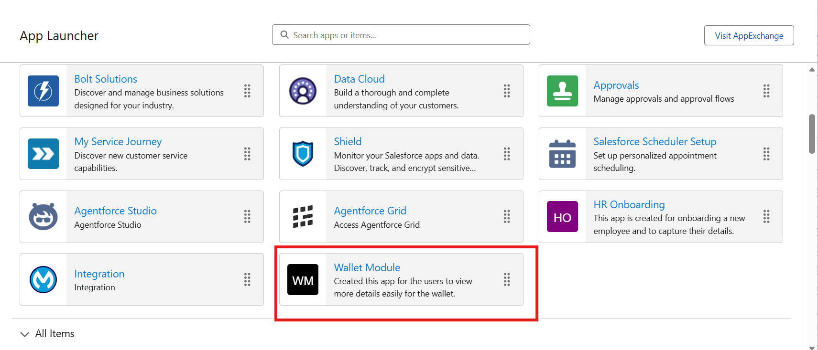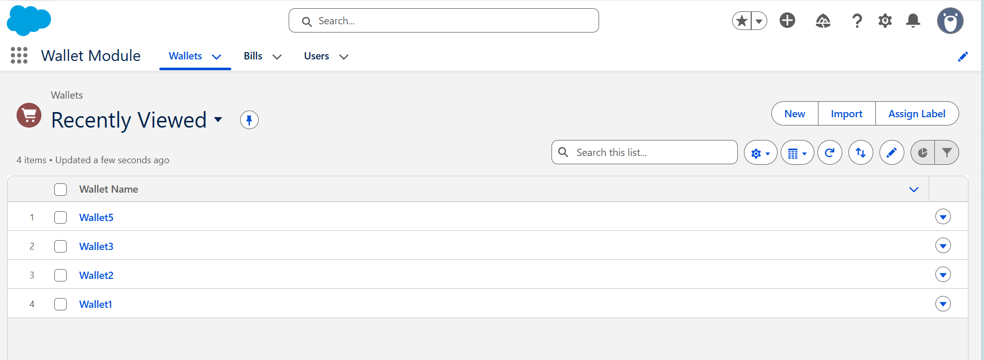
● A dashboard for wallet, in the dashboard you are expected to display reports on Payment methods, expenditure overtime.
